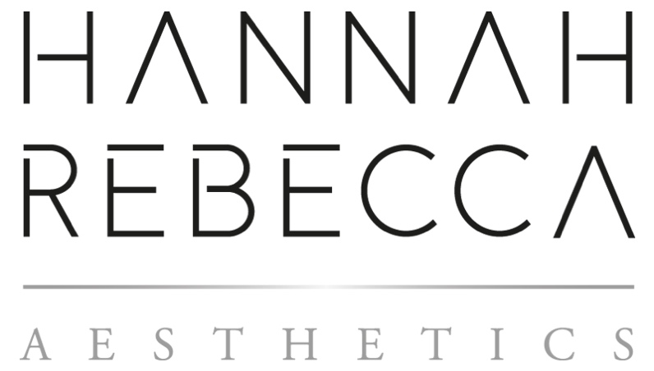

TREATMENT MENU

ADVANCED SKIN TREATMENTS

Hannah Rebecca Aesthetics offers a variety of medical grade skin treatments, tailored to deliver optimum results.

CONSULTATIONS
Skin Consultation £20
Skin Consultation & First Treatment From £40

CHEMICAL PEELS

Classic Chemical Peel £45
HRA Signature Chemical Peel £65

DERMALUX ® FLEX MD LED THERAPY

Prescription Dermalux® Facial £45
Body Treatments QUOTE ON CONSULTATATION

DERMAPLANING

Classic Dermaplaning £40
HRA Signature Dermaplaning £60

DERMAPEN 4 ™(Microneedling)

Face £150
Face and Neck £165
Face, Neck and Décolletage £180

DERMAPEN 4 ™(Microneedling) AND UBER PEEL

Face £180
Face and Neck £195
Face, Neck and Décolletage £210

RELAXATION

HRA Tranquillity Facial £40

TREATMENT ENHANCERS

Enhance your experience by adding on additional mini treatments. Please note these can only be added onto an existing facial treatment.

Casmara Jelly Mask £10
AHA & EGF Serum £4
Dermalux ® LED (15 MINS) £20

SKIN IMPERFECTION REMOVAL

Hannah Rebecca Aesthetics uses advanced techniques and devices to effectively and safely remove warts, verruca’s, milia, seborrheic keratosis, hyperpigmentation etc from the face and body.

Cryopen® (Small area) £55
Cryopen® (Medium area) £80
Cryopen® (Large area) £95
Milia Lancing FROM £35

MEDICAL SCARRING

Using the advanced DERMAPEN 4 ™, we can help resolve an array of medical conditions such as: post-operative scars, stretch marks and hair thinning.

Informal Consultation (Redeemable against treatment) £20
Small Area £70
Medium Area £80
Large Area £90
Extra Large QUOTE ON CONSULTATATION
Hair Thinning £150

INJECTABLE AESTHETICS

Hannah Rebecca Aesthetics implements safe, ethical and evidenced based knowledge throughout all injectable treatments. All treatments require a face-to-face consultation to establish an achievable and realistic treatment plan prior to commencing treatment.

Informal Information Consultation Complimentary
Formal Prescription Consultation (Redeemable against treatment) £20
1 Area £170
2 Areas £190
3 Areas £220
4 Areas £270
Lip Flip / Peri-Oral £170
Bunny Scrunch £170
Pebble Chin £170
Downturned Mouth £170
Nefertiti (Neck) £220
Jaw Slimming (Bruxism) £220
Excessive Underarm Sweating £300
ANTI-WRINKLE INJECTIONS

DERMAL FILLER

Informal Information Consultation Complimentary
LIPS (0.5MLS) £170
LIPS (1ML) £200
CHEEKS (1ML) £250
CHEEKS (2ML) £350
NASOLABIAL (Nose to mouth) 1ML £180
MARIONETTE LINES (Nose to chin) 1ML £180
PERI ORAL (lip lines) 1ML £160

PROFHILIO ®

Informal Information Consultation Redeemable against treatment) £20
Initial Treatments (Two sessions) £430
Initial Treatments (Three sessions) £645
Maintenance Session (One session) £220

